

İstanbul Kültür Üniversitesi

Software Engineering

|  |
| --- |
| APXEIA  IPFS alternatives and SRS edition |
| Instructor: Akhan Akbulut  Assistant: Büşra Kocaçınar |
| May 17  Authored by: Nasibullah Qarizada  Student No: 1900004691  Department: Computer Science |



Contents

Contents ii

1 Introduction 1

1.1 IPFS Alternatives 3

1.1 this week on SRS 3

1 Parts Applied This Week 4

2.1 Chatbot Configuration 4

What are IPFS API alternatives?

As far as we know that [IPFS](https://docs.ipfs.io/concepts/persistence/#pinning-services) API provides us a limitation of 100MB data upload per file in short term storages, we’ve been requested to be researching the alternatives.

## [**File.io API**](https://english.api.rakuten.net/stefan.skliarov/api/Fileio)

[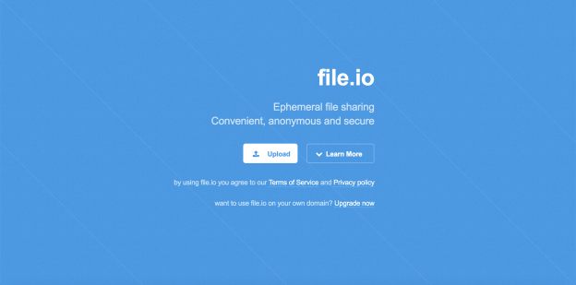](https://english.api.rakuten.net/stefan.skliarov/api/Fileio)

File.io is a project of humb.ly. It was created simply out of the joy of trying to build cool things on the internet.

[**API Features:**File API](https://english.api.rakuten.net/stefan.skliarov/api/Fileio) Allows users to share files conveniently, anonymously, and securely

**Free Storage capacity for free:**100 daily file uploads, with a maximum upload size of 100 MB

**Price:** $249 monthly (Unlimited uploads) maximum upload size of 25 GB

Spideroak:

[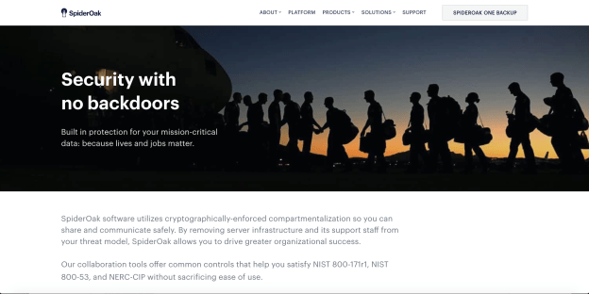](https://spideroak.com/apis)

Initially released in 2007, SpiderOak is a collaboration tool, online backup and file hosting service that allows users to access, synchronize and share data using a cloud-based server, offered by a company of the same name.

[**API**](https://spideroak.com/apis/accounts/docs/)[**Features**](https://spideroak.com/apis/accounts/docs/)**:** Spider Oak offers support for uploading and downloading data, along with file management functions like listing and deleting data stored. This API supports different authentication methods for different uses. However, a simple password-based HTTP authentication is typically used for authentication.

**Free Storage capacity for free:**Only offers a 21-day free trial

**Price:**$5 monthly for 150 GB

Creating Distributed System from Start:

Although paying some amount of money to services such as IPFS, Arweave, FileCoin, SpiderOak, is saving from time, they can be also so expensive after a while and reaching to a big community of users. therefore, creating a Distributed System like them is also among alternatives. And the requirements for creating such a system would be huge amount of time, skills, and money.

Software Requirements Systems Document:

Other Supporting Information:

Technical Assumptions and constraints:

